**Step 1:** Open Jenkins and click **"New Item."**

**Step 2:** Enter a project name and select **"Freestyle Project,"** then click **OK.**

**Step 3:** In the **General** tab, scroll down to the **"Build"** section.

**Step 4:** Click **"Add build step" → "Execute shell."**

**Step 5:** Enter your shell commands in the provided text box.

**Step 6:** Click **"Save"** to apply the changes.

**Step 7:** On the project page, click **"Build Now"** to start the job.

**Step 8:** The build status will appear in the **Build History** (left-side panel).

**Step 9:** Click on the latest build (#1, #2, etc.) and select **"Console Output"** to view logs and results.

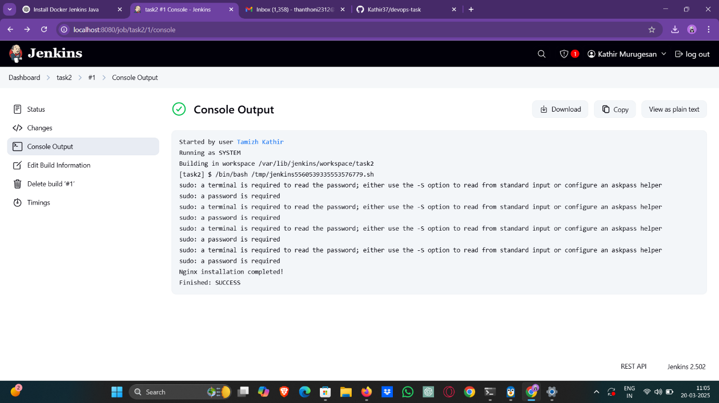

**Command:**

echo “Hello, World!”

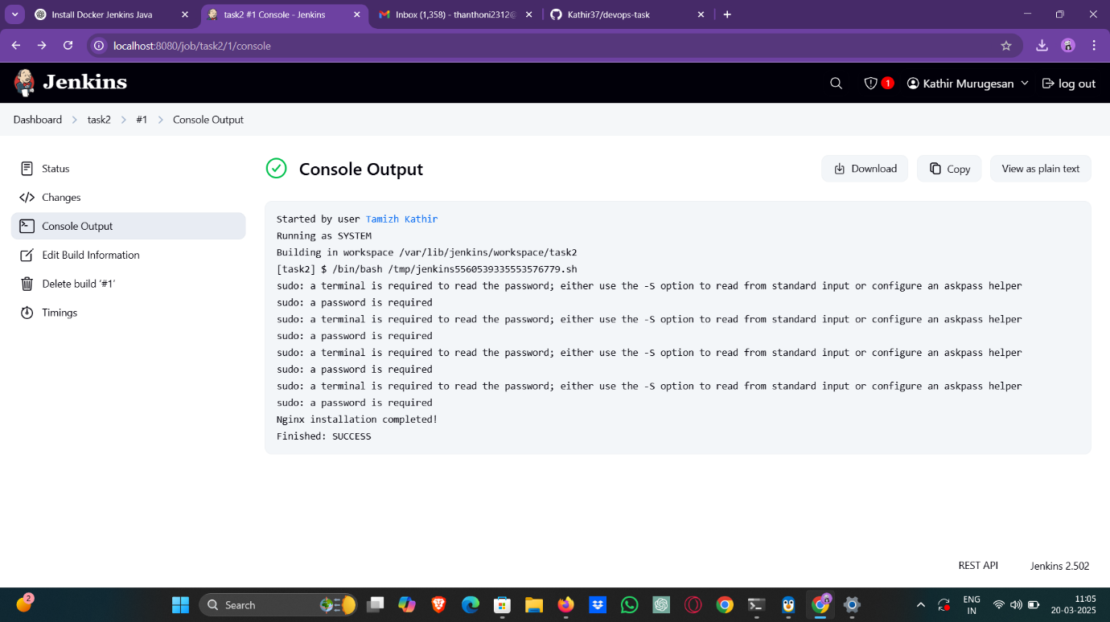

**Command:**

Sudo apt - get update

Sudo apt – get install nginx